Trainer Report: Peer Coach Programme Partners in Learning


Trainer Name: Saul Pila

Venue: Laerskool Wonderboom

Date of training: 16 February 2008

Indicate with an X which Peer Coach Sessions were included in the training:

1 | 2 | 3 | 4 | 5 | 6 | 7 | 8
X

For each item place an X in the box that best describes your response.

 |  | No | To some extent | To a great extent | Yes
1 | Sufficient computers were functional for a 1:1 computer to user ratio |  |  |  | X
2 | Required equipment was available and functional (data projector, Internet access, video sound capability) |  |  | x
3 | The required software was loaded |  |  |  | X
4 | Participants were able to log in and be ready for starting the course within a reasonable time |  |  |  | X
5 | Participants were competent ICT users |  |  |  | X
6 | Participants had some experience of integrating ICT |  |  | X
7 | Participants were able to work constructively in groups. |  |  |  | X
8 | Participants were engaged by the activities and actively participated. |  |  |  | X
9 | Participants appeared to find the topics useful and interesting. |  |  |  | X
10 | The whole group reporting and sharing was useful in capturing the collective knowledge of the group. |  |  |  | X
11 | The participants used the facilitator guideline and found this useful |  |  |  | X
12 | You felt that participants left the workshop with some confidence to implement the Peer Coach Programme |  |  |  | X
 | Session 1 only
13 | Participants communicated well with their principals in workshop sessions |  |  |  | X
14 | Participants were able to join the peer coach community |  | X
15 | Participants were able to contribute to the peer coach community |  | X
16 | Peer coaches understood the possible roles that they could fulfil |  |  |  | X
 | Session 2 only

General comments: We had more than enough computers. The participants were eager to learn. This was voiced out by some SMT Members who wanted to join and become the Peer Coach.

Most participants struggled to go through the Communities during the Meet and Greet activity. In most case when they opened the blog, Tshwane Peer Coach Blog was no accessible. We spent a lot of time trying to help them. I then decided that they should try and access it later at their school and do that activity.

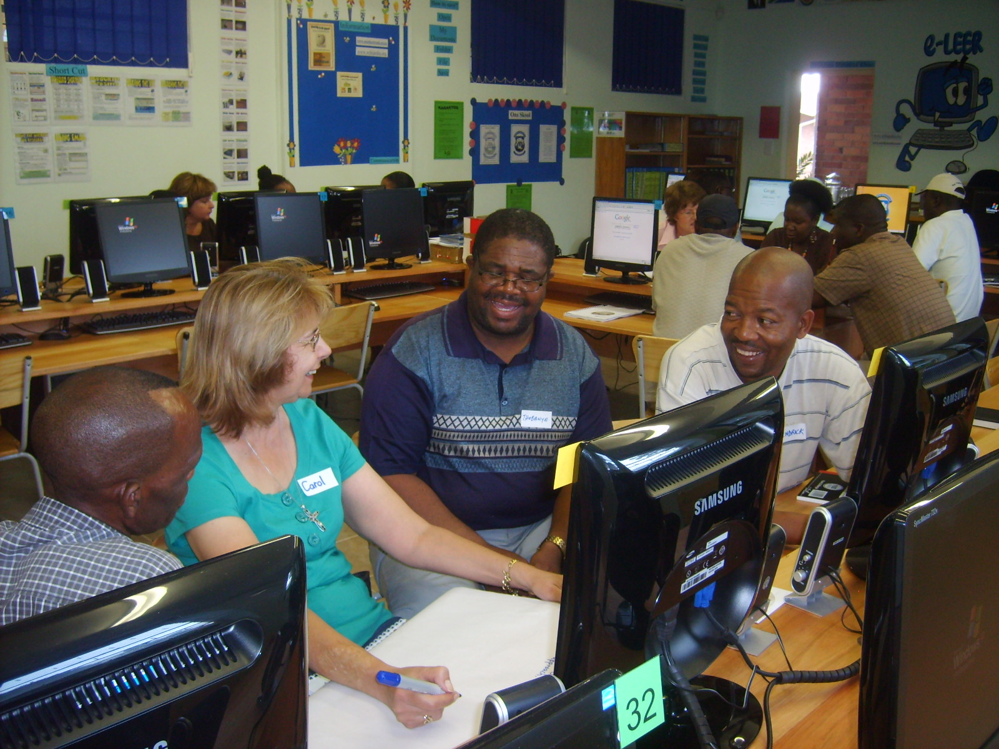

Peer Coaches busy at work.
From left to right : Mr Molebale L.P (Principal of Motshegofadiwa Primary) , Carol Coleman (PC Northridge Primary), Dikotope T.D ( PC Soshanguve Sec) and Botolo M.H, HOD from Modilati Middle School)

HIGHLIGHTS : The Principals and HODs that attended support the Programme wholeheartedly and they assured me that they will take it forward. They also participated in most activities that we did. One HOD, Lu M Kruger from Laerskool Wonderboom has even went to an extend of requesting to be a Peer Coach and that she should be allowed to attend and complete all the remaining sessions. You will advice me on that, Gerald. The Principal of Motshegofadiwa did not want to leave after lunch. He stayed up the last minute. The participants showed a lot of interest and that encouraged me a lot.

The Computer Lab we are using is one of the best around. The Peer Coaches have also requested me to talk to the Principal so that we do not rotate and that we should use the same Centre up to the last session. Is this a good idea?

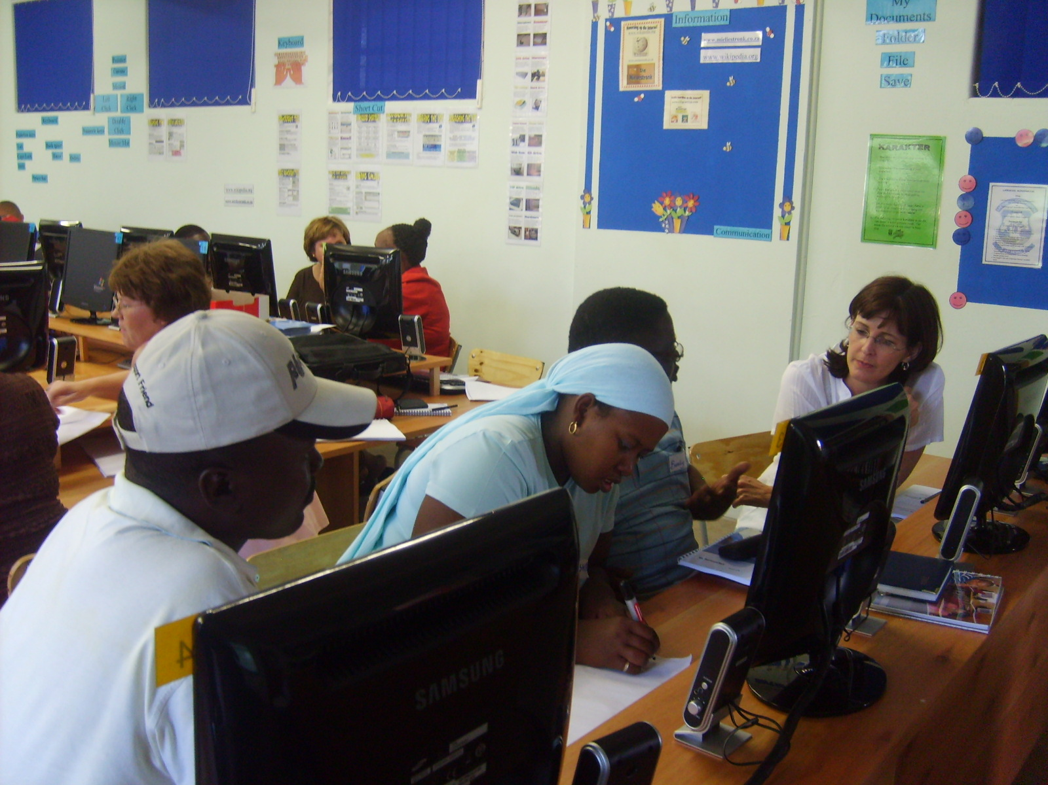
Busy about the Developmental
Programme that influenced their
Work as a teacher/principal.

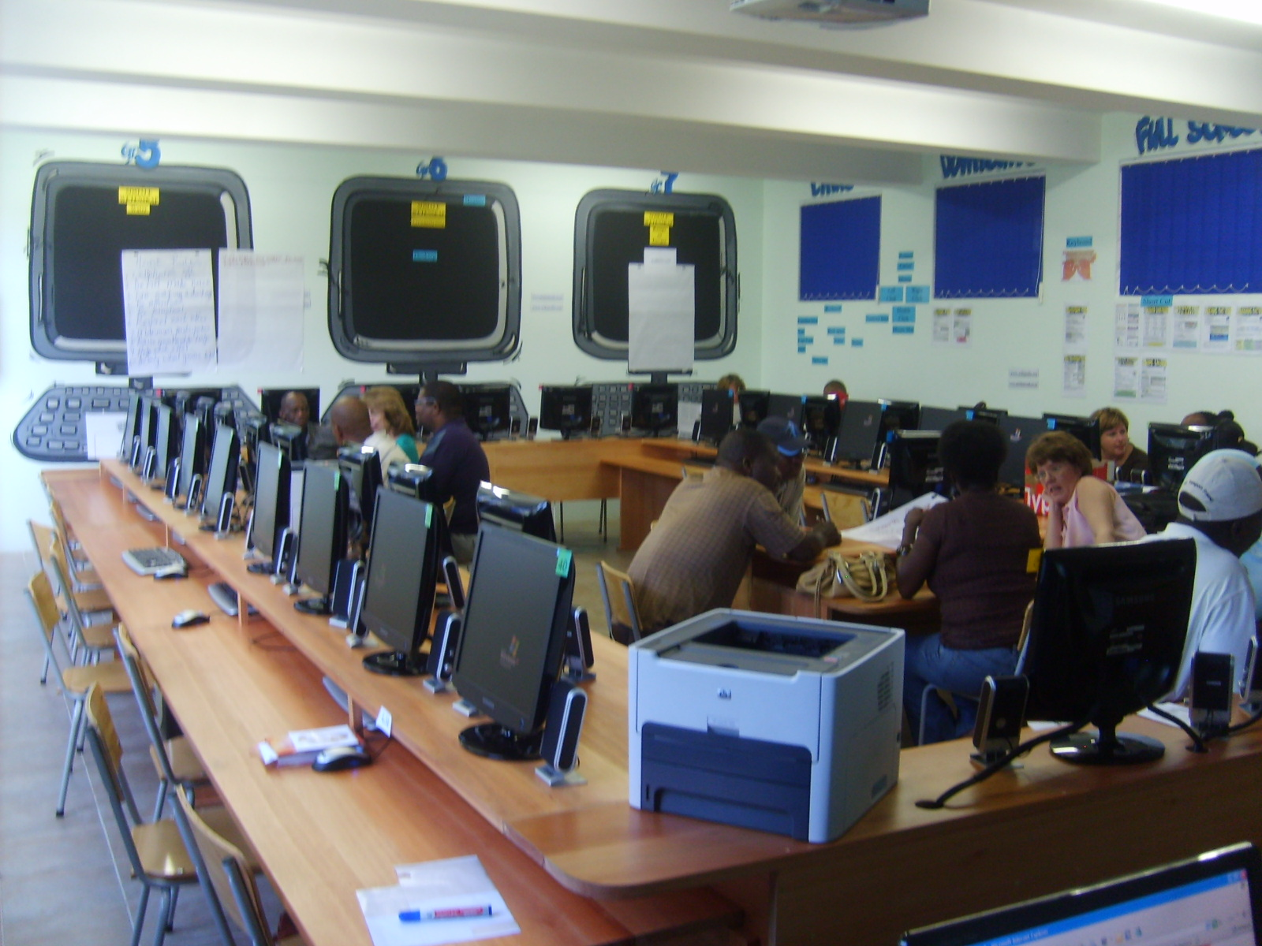

The computer Centre of Laerskool Wonderboom.

DIFFICULTIES/ CHALLENGES

A. The Peer Coaches from the following three schools did not attend at all :

NO | Name of School | Peer Coach
1. | State President C.R Swart | Johan Barkley
2. | Prospectus Novus Primary | Van Wyk S.J
3. | Laerskool Voorpos | - Corine Lategan  - Erika Hartzenberg

B.The following schools did not present 100% Peer Coaches . The following were absent :

NO | Name of School | Peer Coach
1. | Makgetse Secondary | - Cherick Masilo  - Oupa France Tsime
2. | Lethabong Secondary | 1. Sebego Godfrey Thobejane

